**CS306 PROJECT STEP 2**

Ege Öngül

Elif Ilgın Arat

STEP 1:

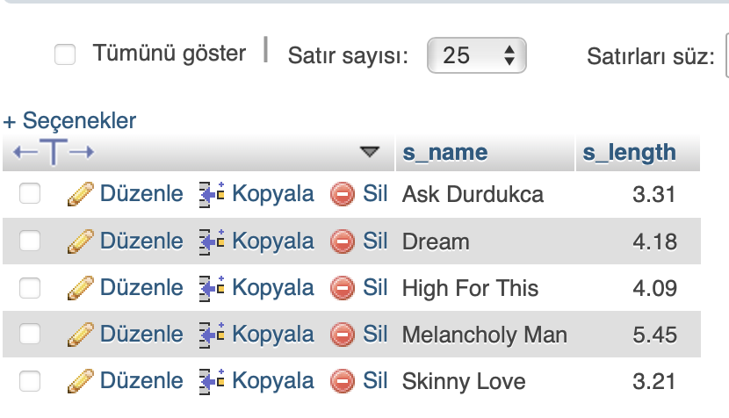 As a first step, we created a database using MySQL and named it as cs306_project. Then with using the CREATE TABLE statement we created a table named as songs, which is one of the few tables from our future project. Then we added 2 attributes: s_name and s_length. S_name is the song name and s_length is the length of that specified song. Since there is only 1 length for each song, given the song name we know the length of it for sure, s_name is the primary key.

STEP 2:

tablo içeren bir resim

Açıklama otomatik olarak oluşturuldu For the second step, using the sublime text editor, we created our main page and called it index.php. In the main page, the first thing that users see is the name of the project, BELL SONG. And there are our names under it, but with smaller font size. Then there are 3 forms with different functions which will be explained later. And for the last thing, there is an visual of the whole table. First row is the identifier row and the others are the songs and their lengths.

STEP 3:

tablo içeren bir resim

Açıklama otomatik olarak oluşturuldu In step 3, we added functionalities to the forms such as inserting a song to songs table, deleting a song and classifying the songs in the songs tabler. Inserting song takes 2 parameters, song name and song length. Then inserts that song into the table. If there is a duplicate, song is already in the list, it does nothing. But if we write “Yıldızların Altı” “3.25” the table will change as the following:

As you can see, “Yıldızların altı” is inserted into the table.

Remove Song function takes only the name as a parameter and it deletes the row which contains that name. If we write “Yıldızların Altı” to Remove Song the table will change as the following.

tablo içeren bir resim

Açıklama otomatik olarak oluşturuldu

As you can see, “Yıldızların altı” is deleted from the table.

Classify Songs function takes a double number for the parameter and it sends the user to the second page, which is the “classified data” page and it shows all the songs that are strictly longer than the given double number. So if we give 4.10 as a parameter, user will see a new tablo içeren bir resim

Açıklama otomatik olarak oluşturuldupage like the following:

As you can see, the table is in the same format with the previous one but cutted according to song lengths. And there is a link in the botto left of the page, which sends user to the main page.